Knowledge Organiser
Dragonflies
Forces
Term 2 – 2020/2021
Vocabulary |  | Fascinating Facts about Forces | Newton and Gravity
force | A push or a pull | - Forces are all around us and acting on us at all times. We can’t see these forces, but we can often feel them!  - When you go swimming, you can feel the water pushing back against your arms and legs as you move forward. That’s the invisible force of water resistance at work!  - When something moves there are often many forces involved. For example, when you throw a ball, the force of your throw moves it forwards, the force of gravity pulls it down and the force of air resistance slows it down.  - Forces can cancel each other out! If the forces balance, nothing moves. But if one force is stronger than the other, then an object will move.  - Forces can change the shape, speed and direction of an abject.  - If you throw a tennis ball in space – where is no resistance to motion – it would just keep on moving in a straight line with the same speed FOREVER!  - Your weight depends on Earth's gravity. The moon has less mass than Earth, so its force of gravity isn't as strong. This means you would weigh less on the moon than you do on Earth! | Isaac Newton is one of the most famous scientists of all time, and he discovered some amazing things. He was born in Woolsthorpe, England in 1643. He died in 1727 and is buried in Westminster Abbey, in London.  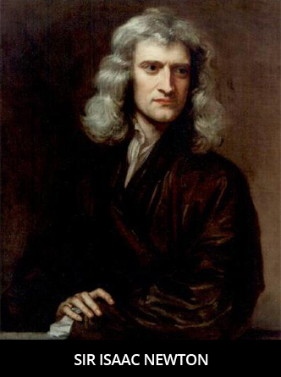  Newton described gravity as a pulling force that keeps people on the ground rather than floating off. He also noted that gravity keeps the moon in orbit. Newton told the story of seeing an apple fall to the ground from a tree which inspired him to wonder why it fell down, rather than up or across. This led to his work on defining gravity. Newton developed the universal law of gravitation, which states that two things will be attracted to one another and that the mass of each object will affect the amount of attraction.
gravity | A pulling force. Gravity is the force by which a planet or other body draws objects toward its centre. The force of gravity keeps all of the planets in orbit around the sun.
gravitational pull | The Earth’s gravitational pull is what keeps us on the ground.
friction | Friction is a force between two surfaces that are sliding, or trying to slide, across each other. Friction always works in the direction opposite to the direction in which the object is moving or trying to move. Friction always slows a moving object down.
weight | The measure of the force of gravity on an object.
mass | A measure of how much matter (or ‘stuff’) is inside an object. It is measured in kilograms. (kg)
Newtons | A unit of measurement named after Sir Isaac Newton. Weight is how strongly gravity is pulling an object down. It is measured in newtons (N).
resistance | A force that acts in the opposite direction of a moving object.

